

Registration Form
"Syria - Challenges of Reconstruction"
Gießen Syrian-Conference of S.I.G.N
(= Syrian International Geography Network)

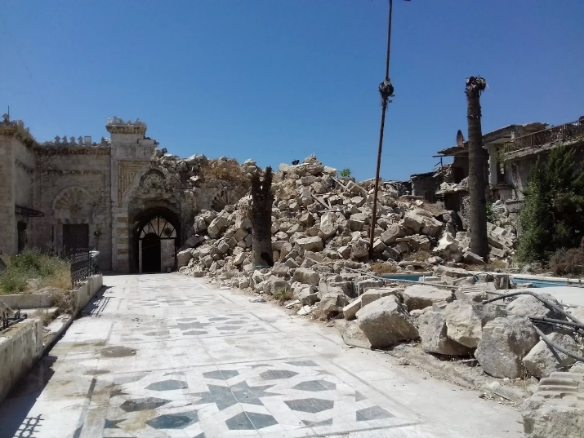
Destroyed Umayyaden-Mosque in Aleppo (Minarett)

The Department of Geography (Section Human Geography and Development Research) at the Justus-Liebig-University Giessen and S.I.G.N. (= Syrian International Geography Network) are pleased to invite to the Second Giessen Syria Conference in cooperation with Alexander-von-Humboldt-Foundation (AvH), Fritz-Thyssen-Foundation and German Academic Exchange Service (DAAD):

8th – 10th December 2017, Opening 2:00 p.m.
Großer Hörsaal Zeughaus, Senckenbergstr. 3, 35390 Giessen

The conference will focus on the challenges of reconstruction in Syria. Scientists from Syria and neighbouring countries, as well as academics from other war-torn countries and representatives of German institutions will discuss aspects of the reconstruction and how to generate and coordinate further activities.
We would be delighted to welcome you and are looking forward to your participation in the conference and your contributions to the discussions. To facilitate our preliminary planning, please fill in the registration form below and send it to Prof. Dr. Hussein Almohamad (hussein.almohamad@geogr.uni-giessen.de), Prof. Dr. Andreas Dittmann (andreas.dittmann@geogr.uni-giessen.de) or to Dipl.-Geogr. André Staarmann (andre.staarmann@geogr.uni-giessen.de). The participation in the lecture program is free of charge.

Surname, Name:
Institution/Company:
Street Address:
Postal Code, City:
Country:
E-Mail-Address:
Date of Arrival:

Day of Departure:

