Quantifying and Tackling On-Farm Food Loss: My STSM Experience with Fundació Espigoladors
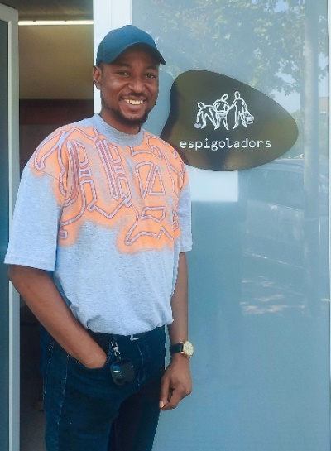
Each year, about 14% of the world’s food is lost from harvest to retail, and in Europe, over 80 million tonnes of food are wasted annually. A large part of this waste happens even before the food leaves the field. These pre- and post-harvest losses not only threaten food security but also waste the water, land, energy, and labour invested in food production. To tackle this issue, precise and consistent measurement of food loss is vital. My Short-Term Scientific Mission (STSM), from June 18th to July 18th, 2025, under COST Action CA22134, aimed to understand food loss in the EU, verify the usability of the EU FOLOU Food Loss Quantification Manual, and examine how to adapt it for other global settings. In partnership with Fundació Espigoladors, a non-profit organisation based in Catalonia, I participated in practical fieldwork combined with research analysis. This allowed me to work directly with an organisation that operates at the crossroads of food recovery, social inclusion, and sustainability.
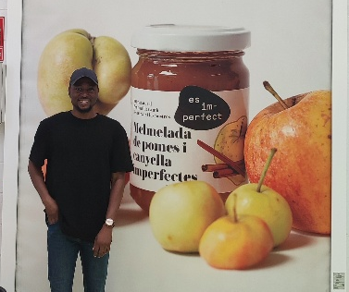
Who are Espigoladors
Fundació Espigoladors is a social enterprise dedicated to addressing both food loss and waste and social inequality. The organisation recovers surplus produce that would otherwise be left in the field due to aesthetic standards, market constraints, or logistical limitations. This recovered food is redistributed to social organisations or transformed into quality products under their brand, "Es Im-perfect." Their approach integrates three core areas: food recovery (gleaning), by organising volunteers to harvest uncollected crops which are entirely donated to social entities; food transformation, by purchasing “surplus” produce from farmers at a fair price and employing people in vulnerable situations to process it into sauces, jams, and preserves; and education, by raising awareness through campaigns and workshops on food waste and responsible consumption. Since their founding, Espigoladors has recovered hundreds of tonnes of fruits and vegetables, collaborated with over 250 farms, and created dignified employment opportunities within their social innovation model.
Insights from Field-Level Measurement
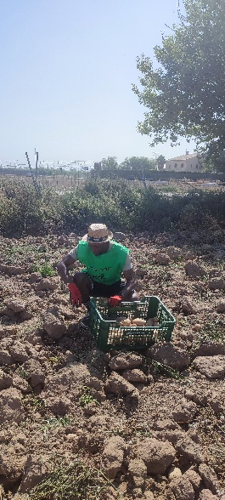
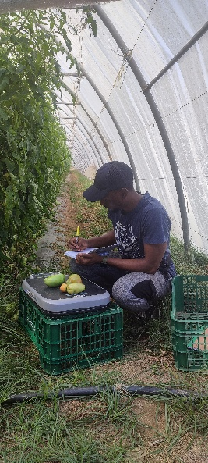
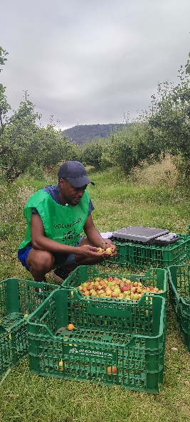
Part of the aims of my STSM was to evaluate whether tools like Google Maps and satellite imagery could be practical, low-cost solutions for estimating cultivated field areas. These tools are especially useful in regions lacking access to specialised equipment and can assist farmers and stakeholders in understanding field sizes, planning harvests more efficiently, and estimating potential food losses. To test this, I collaborated with various research and gleaning teams at Espigoladors to develop a simplified protocol and applied it in the field. Using the EU FOLOU Food Loss Quantification Manual, I measured food loss in crops such as pears, potatoes, and tomatoes. The fieldwork was a joint effort; I worked with the research and gleaning team and over 20 volunteers, helping to recover 600 kg of pears and 965 kg of potatoes. This practical experience was invaluable in recognising the real-world challenges and opportunities in food loss measurement. I also featured in a short video on food loss quantification https://youtu.be/Du0-gFf0YLs?feature=shared.

The STSM Contribution to My Doctoral Research
This STSM experience marked a pivotal moment in my doctoral research, which concentrates on uncovering the causes of food loss at the farm level. I developed a deeper understanding of both the concept and various aspects of food loss, including its direct and systemic causes during harvest. It also provided practical insights into data collection, stakeholder engagement, and how contextual factors such as labour shortages, weather variability, and market dynamics influence farm-level losses. These insights have shaped the next stage of my research, aimed at creating adaptable food loss measurement frameworks for the Global South. In many low- and middle-income countries, formal data systems are either limited or absent. I intend to build upon the methods tested during this STSM, such as simplified mapping tools and structured interviews, and adapt them to resource-constrained settings. My time with Espigoladors has demonstrated the potential of low-cost innovation combined with community-led action—a model that could be especially impactful in such environments.
The EU FOLOU Food Loss Quantification Manual
A major outcome of this STSM was contributing to the ongoing development and feasibility testing of the EU FOLOU Food Loss Quantification Manual. While the manual has yet to be published, the field experience allowed me to assess its practicality and adaptability. The manual is designed to standardise food loss measurement across EU member states, offer validated tools that are accessible and easy to use, support evidence-based policymaking, and provide a flexible framework that can be applied beyond the EU. This flexibility is especially important for countries in the Global South, where the lack of reliable tools has long hindered the development of effective food loss strategies. Contributing to the manual’s real-world validation was both an honour and a meaningful addition to my research and professional growth.
Moving Forward
My experience with Fundació Espigoladors brought the issue of food loss into clear focus, not as an abstract challenge but as something that can be measured, understood, and addressed with practical tools and community engagement. I plan to apply the insights gained from this STSM in my doctoral research and ongoing contributions to the COST Action CA22134 network. Looking ahead, I will continue working with Espigoladors and similar organisations to refine quantification protocols, share best practices, and support collaborative learning across countries. I have learnt that accurate measurement is the first step to effective intervention. By improving how we quantify on-farm food loss, we can manage it more strategically and build a more equitable, efficient, and sustainable food system. This experience has underscored the value of grounding research in fieldwork and ensuring that solutions are both scientifically sound and operationally realistic, within Europe and far beyond.
Acknowledgements
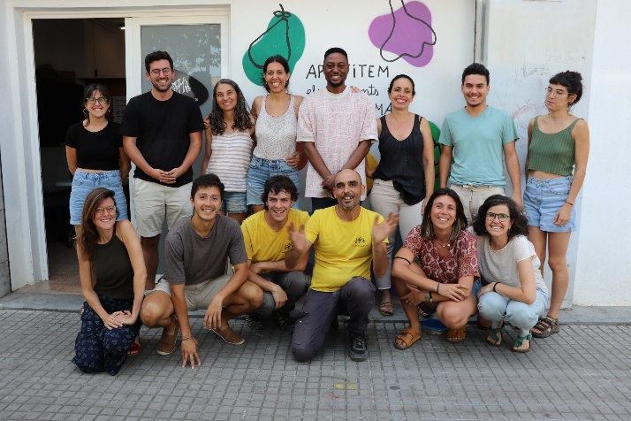
I would like to express my sincere appreciation to COST Action CA22134 for funding the Short-Term Scientific Mission (STSM). I am also grateful to Fundació Epigolardors and its incredible staff for hosting me during my stay. Additionally, I extend my thanks to the German Academic Exchange Service (DAAD) for funding my PhD through the International PhD Program in Agricultural Economics, Bioeconomy, and Sustainable Food Systems (IPPAE) at Justus-Liebig University in Giessen, Germany. I am especially grateful to my esteemed PhD supervisor, Professor Dr. Stefan Whalen, for allowing me to undertake this mission.

